REPORT 20-21
Strength
Teachers: 58
Supporting Staff: 17
Administrative Staff: 3
Total: 78

Student Strength:1779
Boys: 1111
Girls: 668

Class XII: 117. Class X:162

Academics: This session experienced both online and offline classes. As CBSE cancelled class X and XII board exams, result was finalized based on the criteria sent by CBSE.

The offline classes for IX to XII started on 1st September'2021. The attendance varied from 80-90%. The e-school reopened for LKG to VIII on 8th November' 2021 with 70% of parents sending their wards to school. But the school closed again due to rise in pollution. After the winter break, the offline classes for IX-XII resumed from 7th February' 2021. The CBSE board exam of class X and XII was conducted from 30th November to 21st December'2021 in the school.
Xth pass percentage:
XIIth pass percentage:

EXTRACURRICULAR ACTIVITIES AND COMPETITIONS
- Regular workshops and competitions such as handwriting, spell bee, poem recitation, patriotic speech, painting competitions were conducted online throughout the entire year for the overall growth and development of students. Various webinars and training programs were conducted for both teachers and students.
- Approval to begin NCC junior air force girl's wing with 25 carats, senior boys NCC wing with 27 carats along with existing 50 carats. Mrs. Malvika, new NCC incharge, went for training for 3 months to Chennai.
- The Rotary club in association with Visions Spring, organised a free eye checkup camp and distributed 107 spectacles to students and staff

INFRASTRUCTURE DEVELOPMENT
- A new lift is being installed by Schindler India Pvt. Ltd.
- Overhead projectors installed in the computer lab and auditorium.
- Fencing of the ground.

STUDENTS
- ICICI foundation conducted a webinar on Financial Literacy for students of Commerce stream. 10 students were selected to undergo training to develop their critical thinking and analytical skills and work on specific Stem, through remote learning led by Ryan Jawa and volunteers from US.

- Career Guidance, Counselling and life skills for classes IX and XII students were conducted through UNICEF partnered with iDream Careers (CBSE).

- Interact Club of the school in association with Microsoft team conducted a webinar on Cyber security and cyber bullying.

- Desh ke Mentor, the nation's largest mentoring program launched by Delhi Government was attended by Class IX to XII students of DSKE, to help in career exploration journey, safe space for discussing career and life choices, in-taking informed decisions.

TEACHERS
Teachers underwent continuous training for their professional development.
- Online training program for upskilling teachers on new age technology was conducted.
- Desh ke Mentor, by Delhi Government conducted a webinar on Reading Mission and Career exploration journey.
- Adolescent Peer Educators Leadership program for enriching life skills, holistic health and wellbeing of the students in collaboration with Expressions India to enrich the climate for healthy and happy schools.
- Training on hybrid learning by Microsoft Education and Tech Avant- Gadre
- Coding conducted by CBSE in partnership with Microsoft.
- Integration of arts and culture in teaching learning practices conducted in collaboration with Google Art and Culture.

FUNCTIONS
- Virtual Republic Day
- Teachers Day Celebration
- Farewell (Class XII)
- Virtual Christmas Day Celebration
- Virtual Founders Day Celebration

VISITORS
Justice Kurien Joseph visited Deepalaya on 27th March 2022.
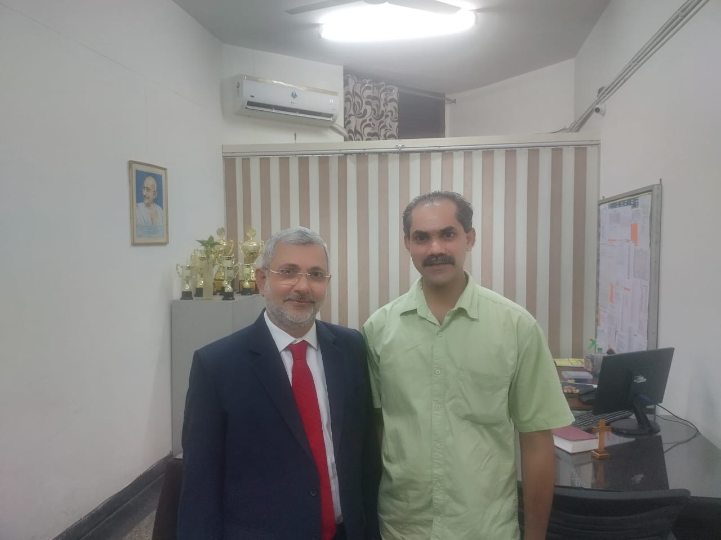
RESIGNATIONS
The following staff and teachers resigned from their duties.
Mr.Sandeep Guleria:Senior Executive Administrator
Mr.Ateeq Ahmed:School bus driver
Mr.Surender Pal:School bus conductor.
FACULTY
Mr.Digvijay Singh
Mrs Baishali Bhattacharjee
Mrs Surabhi
Ms Rosy Saji
Ms Jisha Mathew.
Ms Sheeza Khan.

NEW RECRUITMENTS
Administrator:Rev.Dr Aji George
Ms Monioka
Mrs Das Geeta
Ms Himani

Present Principal of the school is Mr Shaju P.P.
Mr.A.J.Philip relieved his duties from Manager Deepalaya .This was further taken over by Dr.Sakhi John who further handed over the duties to Dr Georgs John .Dr George took over from Ist April as the Manager of Deepalaya.

SUCCESS STORY
Three promising students of class X TAKSH BAMNAVAT,NIKITA KACHCHAP,POOJA YADAV of Deepalaya have done a remarkable job by authoring and publishing their books on digital platform.
The books are:
THE LIST FRIENDSHIP
PHANTOM TALES
INDIA INNOVATION AND CONTRIBUTION
MYTHOLOGICAL WEAPONS.
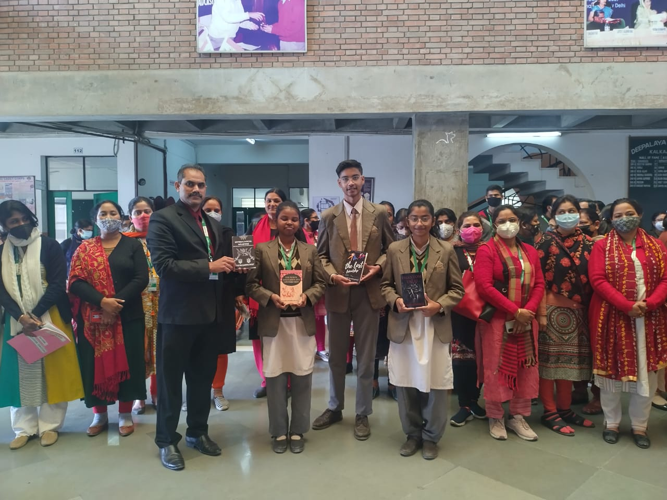

NEW GOALS FOR 2022 SESSION
- Inauguration of the Pre primary wing with a makeover was done on the 8th of April 2022 .
Deepalaya Music Society too was inaugurated on the same day ,8th April 2022.

DSKE has a strength of 1684 students as on April 2, 2022 and this will go upto 1800 in July when the class XI admission is completed. There are 60 teaching and 17 non-teaching staff.
The CBSE practical examination of class XII is going on. The term 2 board examination of classes X and XII will begin from April 27 and May 7 respectively.

The new academic session for classes I to XII started from April 1, 2022, and for the students of pre-primary will begin from April 4, 2022. Many indoor and outdoor games and activities are being rolled out in the new academic session for which coaching will also be provided.

Every student should select one activity each from outdoor, indoor, and club according to one's interest and ability. The following are the different activities and clubs we plan to provide the students with the motto of 'enabling self-reliance':

INDOOR ACTIVITY
VOCAL-CLASSICAL
VOCAL-WESTERN
KEYBOARD
GUITAR
TABLA
DRUM
DANCE-CLASSICAL
DANCE-WESTERN
PAINTING
SKETCHING
DRAWING
CRAFT
OUTDOOR ACTIVITY
FOOTBALL
CRICKET
BASKETBALL
BADMINTON
THROWBALL
NETBALL
CROSS COUNTRY
LONG JUMP
HIGH JUMP
CLUB
DRAMA CLUB-ENGLISH
DRAMA CLUB-HINDI
NUKKAD NATAK-HINDI
MOCK PARLIAMENT
PHOTOGRAPHY
LITERARY CLUB
DEBATE CLUB
QUIZ CLUB
READING CLUB
MODEL UNITED NATIONS
GARDENING
PHOTOSHOP
CAREER CLUB

