DEEPALAYA SCHOOL
A-14, KALKAJI EXTENSION NEW DELHI -19

Admission Schedule for Entry Level Classes

COMMENCEMENT OF ADMISSION PROCESS AND AVAILABILITY OF FORMS 23-11-2023 (Thursday)

LAST DATE OF SUBMISSION OF APPLICATION FORMS IN SCHOOL 15-12-2023 (Friday)

THE DATE FOR DISPLAYING THE FIRST LIST OF SELECTED CHILDREN 12-01-2024 (Friday)

Upper age limit for admission in entry level classes

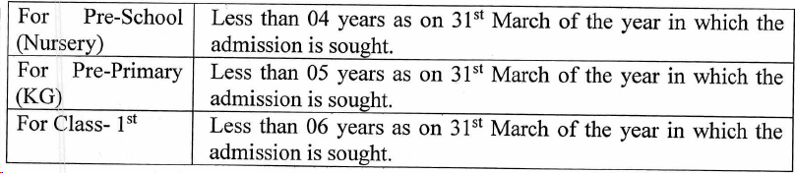

The following documents are to be furnished along with the completed application form:

1 BIRTH CERTIFICATE
2 ADDRESS PROOF- ANY ONE OF THE FOLLOWING:
(A) RATION CARD/SMART CARD ISSUED IN THE NAME OF PARENTS (MOTHER/FATHER HAVING NAME OF CHILD)
(B) DOMICILE CERTIFICATE OF CHILD OR OF HIS/HER PARENTS.
(C) VOTER I-CARD (EPIC) OF ANY OF THE PARENTS.
(D)ELECTRICITY BILL/MTNL TELEPHONE BILL/WATER BILL/PASSPORT IN THE NAME OF ANY OF THE PARENTS OR CHILD
(E) AADHAR CARD/UID CARD ISSUED IN THE NAME OF ANY OF THE PARENTS.
3 VACCINATION CARD
4 PASSPORT SIZE PHOTO OF CHILD - 2
5 PASSPORT SIZE PHOTOS OF PARENT/GUARDIAN - 2 EACH
6 IF SPONSOR /ANY NGO/AGENCY- AGENCY DETAILS)
7 AADHAR CARD COPY OF PARENTS & CHILD
8 COMMUNITY CERTIFICATE (SC/ST/OBC – IF APPLICABLE)
9 MINORITY CERTIFICATE (IF APPLICABLE)

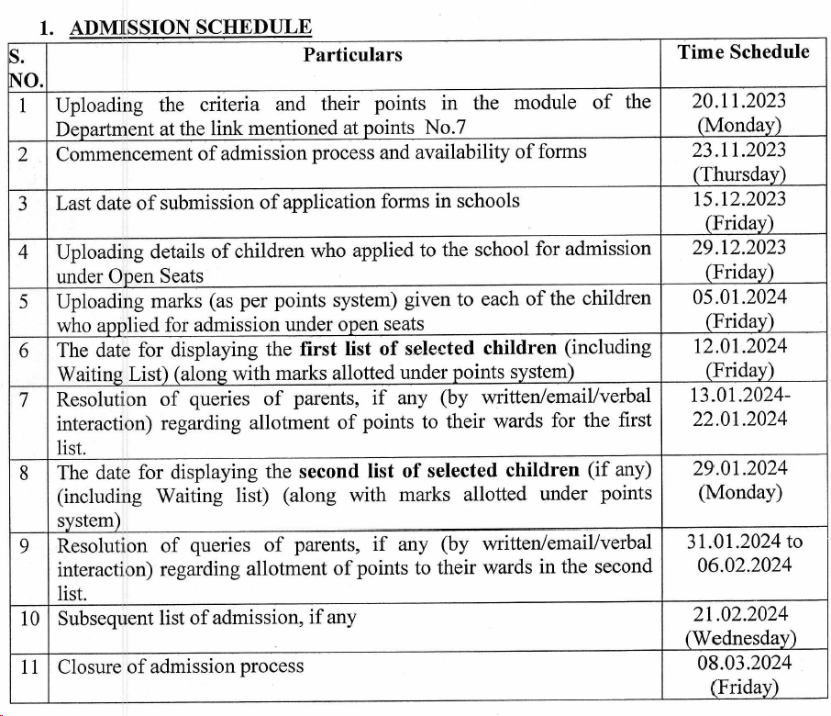

ADMISSION CRITERIA FOR ENTRY LEVEL CLASS

S.NO | CRITERIA | MARKS
1 | Distance -0 km to < 2 km | 25
2 | 2 km to < 3 km | 20
3 | 3 km to < 5 km | 15
4 | 5 km to 10 km | 10
5 | Girl Child | 20
6 | Sibling | 10
7 | Minority Christian | 40
8 | Staff | 10
9 | Alumni | 5

